

Short Exam related to TD3 and Lecture 3 – Computer Vision 2022

½ h – No document allowed except lecture slides

Part 1 (4 points - 20 mns): Geometric transformations (from Exam 2021)

A rectangle with corners A = (0; 2), B = (3; 2), C = (3; 0), D = (0; 0) is transformed by a transformation T so that the new corners are A‘ = (-9; 0), B‘ = (-9; 6), C‘ = (-1; 6), D‘ = (-1; 0).

Question 1 (2 points): Assume T is a similarity transformation (i.e. rotation, scaling, translation). Solve the transformation using the corresponding corners (A; A‘) and (B; B‘). (Hint: Drawing a picture may be helpful for checking the result.)

Ans
B’
C’

A
90°
B

A’
C

A’ = T A (with same scaling factor applied to each dimension)

-9 |  | s cos θ | -s sin θ | t1 | 0
0 | = | s sin θ | s cos θ | t2 | 2
1 |  | 0 | 0 | 1 | 1

Likewise, for B’ = T B

From these equations we can infer that s sin θ = 2 and that s cos θ = 0. So θ =90° and s=2. t1 = -5 and t2=0.

With this transformation C’ ≠ T C, likewise D’ ≠ T D ! But we should also have C’ = T C and D’ = T D. That means that our assumption (T is a similarity transformation) cannot be applied here ! Necessarily, another transformation was used to get A’B’C’D’. This is out the scope of this question

Question 2 (1 point): Assume that T is an affine transformation. Solve the transformation using all four corners of the rectangles. (Hint: You may also use the picture to infer or check the result.)

Ans
C’
B’

A
90°
B

A’
C

A’ = T A

-9 |  | a1 | a2 | t1 | 0
0 | = | a3 | a4 | t2 | 2
1 |  | 0 | 0 | 1 | 1

Likewise, for B’ = T B, C’ = T C, D’ = T D

From these equations we can infer that : t1 = -1 and t2 = 0 (from D) ; a1 =0 and a3 = 2 (from C) ; a2 = -4 (from A) ; and lastly a4=0 (from B).

Oppositely to the previous question the affine transformation hypothesis works well with A’B’C’D’.

Question 3 (1 point): How many point correspondences are sufficient for determining an affine transformation in the general case? Justify your answer.

Ans:
- A 2D affine transformation is defined by 6 DOF, so 3 pairs of corresponding points are enough so solve this transformation (with 2 equations per pair).
- A 3D affine transformation is defined by 12 DOF, so 6 pairs of corresponding points are enough so solve this transformation (with 2 equations per pair).

Part 2 (4 points – 10 mns): Projective, Affine, Similarity, and Isometric Transformations (from Exam 2018)

Question 1 (2 points): Classify each of the following transformations. Fill-in the circle corresponding to the most specific classification.

Ans:
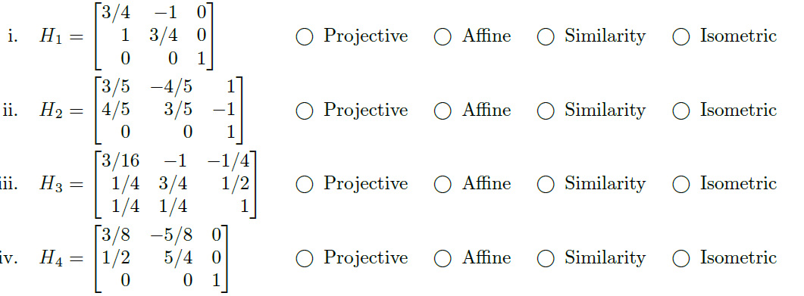

Ans:
If Sin(x) = 4/5 and that Cos(x) = 3/5 this is coherent with the rule Sin(x)² + Cos(x)² = 1. This means that for H2 we haven’t any scaling factor between the 2 rotation parameters. This correspond to an Isometric transform.
If Sin(x)=1 that means that x=90° but as Cos(90°)≠3/4 then H1 cannot be Euclidean (Isometric).

Question 2 (2 points): The figures below show the outputs of applying one of transformations (projective, affine, similarity, and isometric) to a square with vertices at (1,1), (1,-1), (-1,-1), (-1,1). Fill in the circle corresponding to the most specific transformation used to generate each output.
Answer
For case i. we have a rotation close to -45°, a scaling close to 1 (similar in both directions), this correspond to a isometric transformation (no translation here).

